**Project Design Phase - II**

**Data Flow Diagram**

|  |  |
| --- | --- |
| Date | 14 October 2022 |
| Team ID | PNT2022TMID52758 |
| Project Name | Project - Industry Specific Intelligent Fire Management Studies |
| Maximum Marks | 4 Marks |

**Solution Architecture Diagram:**

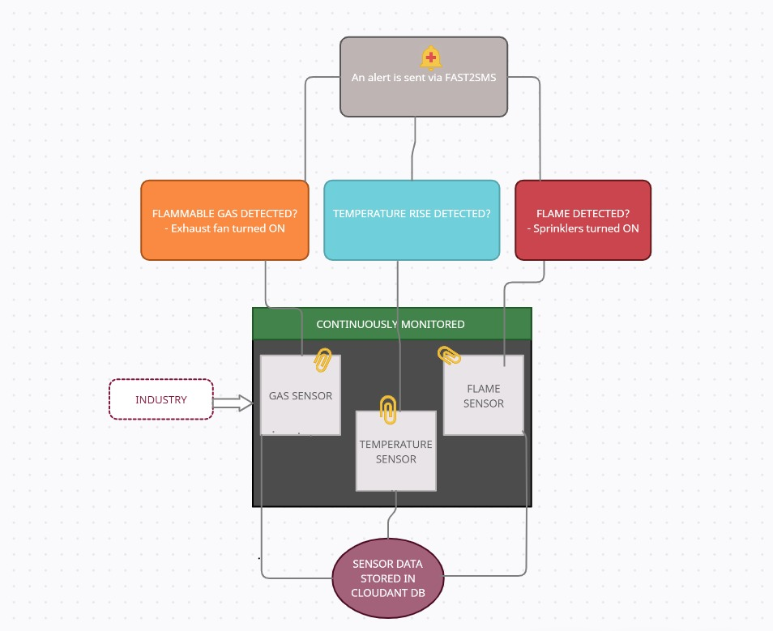

**User Stories**

|  |  |  |  |  |  |  |
| --- | --- | --- | --- | --- | --- | --- |
| **User Type** | **Functional Requirement (Epic)** | **User Story Number** | **User Story / Task** | **Acceptance criteria** | **Priority** | **Release** |
| Customer  (Industry) | Assembling | USN-1 | As a user, I must place the sensors in the appropriate locations. | I have access to my sensor triggers | High | Sprint-1 |
|  |  | USN-2 | As a user, I need to pilot run my hardware to check if it is functioning properly | I can monitor all the sensor values in the serial monitor | High | Sprint-1 |
|  | User Registration | USN-3 | As a user, I can create user accounts for the required software incorporated in the model | I can register & access the dashboard with user Login | Medium | Sprint-2 |
|  |  | USN-4 | As a user, I can check for the proper delivery of alerts and SMS | I can verify the alerts via Fast2SMS | High | Sprint-1 |
|  | Cloud Monitoring | USN-5 | As a user, I can monitor the storage of data in IBM Cloudant. | I can continuously monitor and access the sensor data | High | Sprint-1 |

**TEAM LEADER:**

HARSHAVARTHANA M (1904012)

**TEAM MEMBERS:**

AMIRTHAVARSHINI R (1904001)

ATCHAYA B (1904004)

RAGHAVI R (1904038)

RAKSHEKA R (1904039)